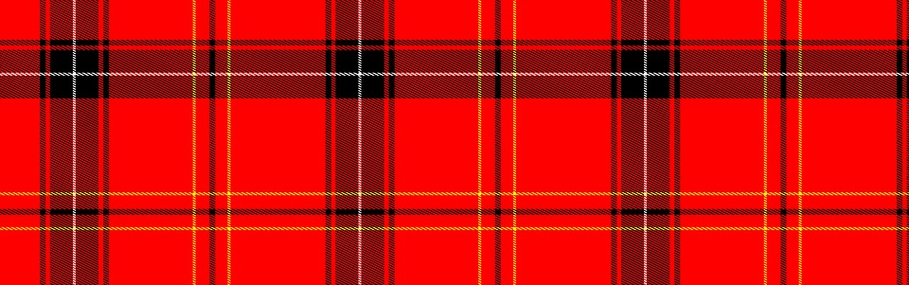
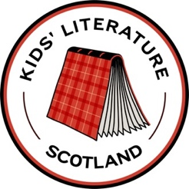
Tick Twelve!

Tick the box when you have read…

- A book (fact or fiction) about Scottish history.

- A picture book set in Scotland.

- A poem by a Scotland based poet.

- An award-winning book set in Scotland.

- A recipe for a traditional Scottish dish.

- A verse novel set in Scotland.

- A book about a Scottish mythological creature.

- A picture book in Scots language.

- A novel about refugees in Scotland.

- An audio version of a Scotland-set story.
(Check out BBC Scotland’s Time for a Story)

- A funny story by an author based in Scotland

- A poem in Scots language

