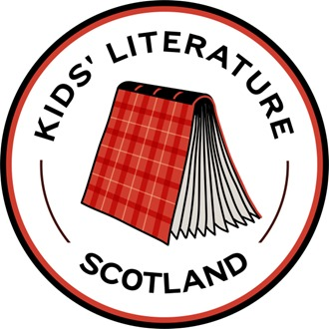 World Book Day

KidLit Scotland Quiz

Round 1

Scottish History

1. Mary 6. The Highland Clearances

2. Longships 7. Paisley

3. The Antonine Wall 8. Culloden

4. Robert Burns 9. A sheep

5. Forth Bridge or Forth Rail Bridge 10. Bannockburn

Round 2

Scottish Creatures: Real and Mythical!

1. The unicorn is the national animal of Scotland.

2. A wildcat

3. Loch Ness

4. Lynx or Northern Eurasian Lynx.

5. Puffins

6. Kelpies were said to trap and drown their victims.

7. Grey squirrels out-compete red squirrels for food and habitat and they carry squirrel pox, which is fatal to red squirrels.

8. Greyfriar’s Bobby

9. Maisie (MacKenzie) and Porridge the Tartan Cat.

10. Both books are about Selkies, shapeshifting mythical creatures.

Round 3

Picture Books: What’s Missing?

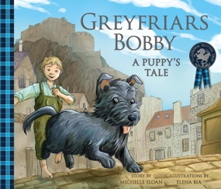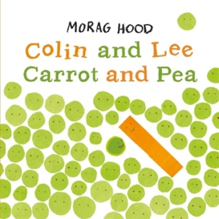

1.Bobby 6. Colin the Pea

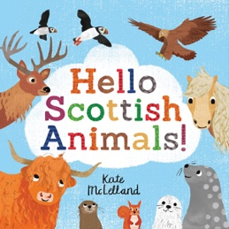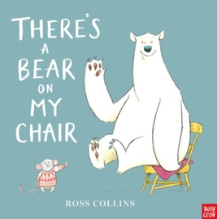

2. Highland Cow 7. Chair.

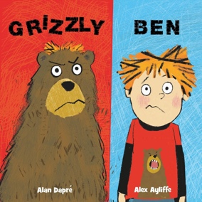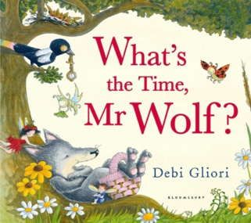

3. Ben 8. Clock (or watch)

4. Magnifying

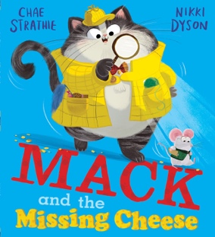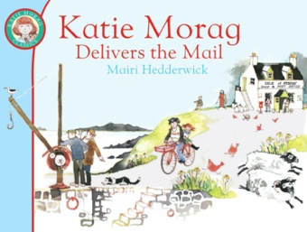 glass 9. Bicycle

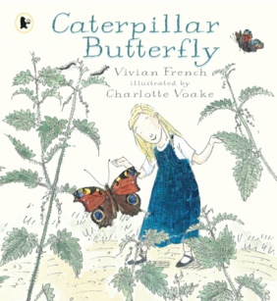

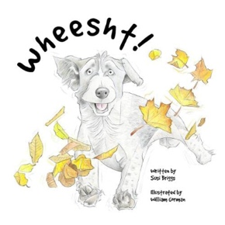

5. Leaf 10. Butterfly

Round 4

Titles: Missing words

1. Monster 6. Gazelle

2. Titanic 7. Ted

3. Willows 8. Promise

4. Luck 9. Viking

5. Robot 10. Bagpipes

Round 5

Julia Donaldson

1. Tiddler 6. The old man tells her to bring her animals into the house.

2. Superworm 7. Santa Claus

3. He sings 8. Cave Baby

4. Shape 9. fly, roar, breathe fire, capture a princess, fight a knight

5. Axel Scheffler 10. What the Ladybird Heard

Round 6

True or False

1. True 6. False. The title is Shadow Keeper

2.True 7. True

3. False, A.A. Milne was based in England. 8. True

4. True 9. False. Alan is a Scottish Primary Teacher.

5. False, Alan is the author 10. False. The book is set in Dundee.

Round 7

Book Settings

1. Glasgow 6. The City

2. Blackpool 7. Neverland

3. The Isle of Struay 8. India

4. Hogsmeade 9. Treasure

5. A castle 10. Anders Frang

Round 8

Books in Scots

1. Be quiet 6. Bob Dewar
2. The Tiger who Came to Tea 7. Tatties
3. A puffin 8. Robert Burns
4. To snuggle/cuddle in 9. Revolting Rhymes
5. A mole 10. Yer Daddy’s Mammy