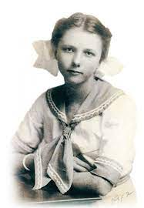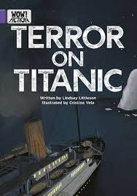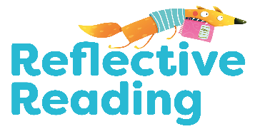

Write the heading ***‘Chapter Summaries’.*** Summarise the events of each chapter briefly (no more than 2 sentences) using ***Who, What, When, Where, Why,*** and ***How*** to help you.

Using a photo to help you, draw a picture ***or*** a ***sketchnote*** of Ruth Becker. Add labels, words and quotes to support your illustration.

**Task Map: Badger Learning**

**WOW! Fiction**

**Terror on Titanicanic: A child survivor's story**

Give three reasons why Ruth is enjoying her voyage on Titanic.

Describe the weather on the night of the ship’s sinking.

Answer the comprehension

questions at the back of *Terror*

*on Titanic*. Write in complete

sentences.

Create a mini fact file on RMS Titanic.

Find out:

In which city was Titanic built?

What were the names of Titanic’s two sister ships?

From which port did Titanic set out on her maiden voyage?

On what date did she leave the port?

How many people were on board the doomed ship?

Ruth’s mother told her daughter to go down several flights of stairs on a sinking ship to get blankets.

Discuss in your group: in this situation, would you have done as you were told or would you have explained to your adult that it wasn’t a sensible thing to do?

Take turns to act out the scene between Ruth and her mother, with Ruth giving her reasons for wanting to stay up on deck.

Look at the illustration in Chapter 1 of a 2nd Class cabin on Titanic.

Do some online research and then create a detailed diorama in a shoebox of a 1st, 2nd or 3rd Class cabin on the ship.

Or

Copy the illustration and add more details, including the other people sharing the cabin, to your drawing.

In your own words, describe the mix of emotions felt by Ruth when she realises her mother and siblings are no longer on the ship. Find three verbs on page 12 which mean the same as ‘spoke very loudly’.

‘Chunks of ice…glittering like diamonds’. Create two other similes of your own to describe chunks of ice.

Connect 4

Create Something Great

Reflect and Respond

Read and Understand

Explore Some More

Infer What’s Not There

Create Something Great

Page 14 Why do you think Ruth decided she ‘had to be brave’?

Page 20 Which side of the ship is the ‘port side’?

Page 26 “And look, Marion… I saved your teddy.” How do you think Ruth is feeling at the end of the story?

Create a presentation or magazine article about one of these famous people mentioned in *Terror on Titanic*: Captain Edward Smith John Jacob Astor Or Design a brand new cover for *Terror on Titanic*. On the back cover, write an exciting new blurb.

Read and Understand