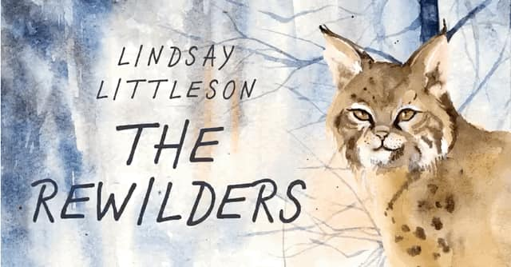

To everyone in the Base at Irvine Royal Academy,
I’m delighted to hear from your teacher that you are going to read my novel, The Rewilders! When my publisher asked me to write a book about the subject of rewilding, my mind immediately went to big predators.
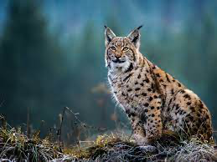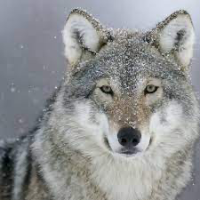

Reintroducing lynx and wolves to Scotland would be an excellent way of keeping deer on the move, which would help to prevent overgrazing and the destruction of young trees. And as Callum tells Esme in The Rewilders, Scotland was once home to both these large predators.
Of course, the reintroduction of wolves and lynx is controversial. Not everybody agrees that reintroducing these animals is a feasible idea, and in The Rewilders I’ve tried to show that different points of view are valid. Personally, I am in full agreement with David Hetherington, author of The Lynx and Us. “When it comes to reintroducing carnivores, starting with lynx is the logical first step…a lynx isn’t a physical threat to humans.”
These stunning animals are so reclusive that seeing them in the wild would be unlikely, but their presence would certainly make a walk in the Highlands a more thrilling experience!
The inspiration for the plot of The Rewilders came all the way from Canada. I read an article online about a Canadian who was riding his bike along a wooded trail in Quebec when he heard a pitiful mewling sound. The man got off his bike and hunted through the undergrowth until he discovered a starving, bedraggled kitten. Quickly realising he’d found a lynx kitten rather than a domestic cat, he took the little creature home and called wildlife experts.
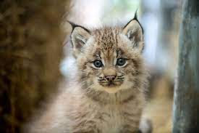
When I finished reading the article, I asked myself the question, What if?
What if two old ladies, out for a walk on a Highland Estate, came across an abandoned kitten, and took it home, believing it to be a domestic cat, and only realised it was a lynx once the animal had grown to size of a Labrador?
Sadie and Jean have been banned from the estate, having been involved in an unfortunate argument with the manager, so Esme and Callum are tasked with the problem of reintroducing the lynx to the wild. Both children, in different ways, are struggling at school and the story is as much about their emotional journeys as it is about the physical quest.
The chapters are written from both Callum and Esme’s perspectives, and will hopefully enable discussions about how our words and actions can impact others and about ways of making the school environment more welcoming and inclusive. There’s always room for improvement!

I really hope you enjoy The Rewilders. Do let me know what you think.
All the best,
Lindsay Littleson

