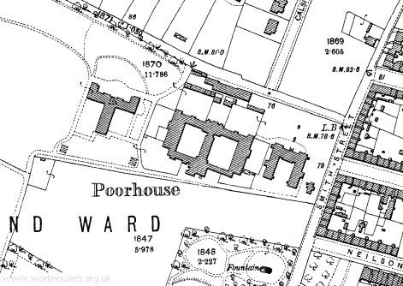

Paisley in the 19th Century had two poorhouses. Due to the collapse of the Paisley shawl industry the poorhouses were crowded in the 1870s, as the only alternative to a life on the streets. Many Paisley men had lost their jobs in the local shawl factories and although there was work for the women and children in the thread mills, the pay was poor, and often insufficient for their housing/food needs.

However, entering the Poorhouse was seen very much as a last resort and many of the inmates were unaccompanied pauper children and elderly people.
This map shows the double courtyard layout of the Abbey Poorhouse. Men and boys aged 8 and over lived in one side and women, girls and boys under 8 lived in the other. Families were split up on entry to the Poorhouse and didn’t get to see each other at all while inside. It was meant to be a hard life as this 1879 inspection report on the Abbey Poorhouse confirms.
“In the poorhouse no inmate is idle…he scrubs floors, makes mats, teases oakum or breaks road metal….he is limited to a prescribed diet. It is satisfactory to the Board.”

This site is aimed at children and has some useful facts.
http://www.primaryhomeworkhelp.co.uk/victorians/workhouses.html
This one has a couple of great photos.
https://www.kidadl.com/articles/victorian-workhouses-ks2-everything-you-need-to-know

This National Trust page has more information on workhouses/poorhouses.
https://www.nationaltrust.org.uk/the-workhouse-southwell/features/life-inside-the-workhouse

