To all the pupils in ……………,

My name is Lindsay Littleson, and I’m the author of A Pattern of Secrets, an adventure story set in Paisley in 1876, during the reign of Queen Victoria.
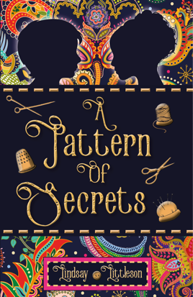
On the novel’s cover, the bright colours of the Paisley Pattern glow against the black background. The little golden thimble and reels of thread give further clues that this is a story set in Paisley’s rich textile past. The boy and girl silhouettes hint at the fact that the story is told from the perspective of two children: Jessie, the feisty daughter of a Paisley shawl manufacturer, and Jim, a homeless boy on a desperate quest to save his family. Their stories are equally important, two separate strands that weave together as Jessie joins Jim in a race against time to solve the mystery of the missing heirloom before Jim’s family is torn apart.
Jessie Rowat was a real-life character who grew up to become one of the influential Glasgow Girl artists.
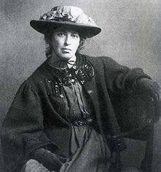
My story focuses on Jessie’s life when she was 12 years old and living in Paisley with her wealthy family. Jim is a fictional character, whose awful experiences in Paisley’s Abbey Poorhouse illustrate what happened to many local families at the time, as the Paisley Shawl industry collapsed and weavers were thrown out of work.
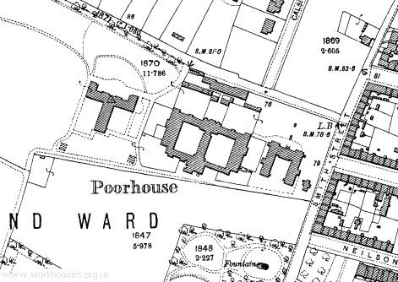
This map shows the double courtyard layout of the Abbey Poorhouse. Men and boys aged 8 and over lived in one side and women, girls and boys under 8 lived in the other. Families were split up on entry to the Poorhouse and didn’t get to see each other at all while inside. It was meant to be a hard life as this 1879 inspection report on the Abbey Poorhouse confirms.
“In the poorhouse no inmate is idle…he scrubs floors, makes mats, teases oakum or breaks road metal….he is limited to a prescribed diet. It is satisfactory to the Board.”
I do hope you get the chance to read A Pattern of Secrets and if you do, let me know what you think.
All the best,
Lindsay Littleson

