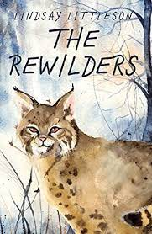
The Rewilders
Find all the hidden words!

h q r v g w x o g z w v x a p  u s e a q d a n g e r o u s r  n u z q e b m d e p e r w q e  t m o u n t a i n s w t o u d  e r t l i h h o l x i o l m a  r l k a p r k p y m l m v p t  l t m m i i m q u h d y e t o  d i v j j r a r e g i t s u r  t e r r i f y i n g d h f t t  y d j m o o r i v e r i f n u  x l y s q g i v u n t p a c k  l y n x e c v i s u i a b q b  i l p f o r e s t o n l g h s  i a j r j c r e w i g j r o u  f x e y b m b s t u n n i n g | predator  lynx  wolves  pack  river  mountains  forest  moor  rewild  dangerous  stunning  terrifying  hunter

Draw this scene!
The lynx’s tawny fur rendered her almost invisible in the dead foliage. Her body was so low, her furry stomach brushed the ground—she was stalking prey.

Colour this Eurasian lynx. 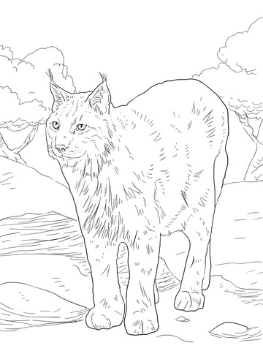
Long ago, Eurasian lynx used to roam wild in Scotland.
Can you draw and name two other large predators that used to live in Scotland?
……………………………. ………………………………

Design a new cover.

- Read the blurb on the book cover and use it to help you create a new cover design.

- Decide what text should go on the front, the back and the spine.
- Next draw a rough design.
- Choose a colour scheme. Think of the title of the book. What colours might suit the theme?
- Lay out your paper for the cover as below and remember that the left will be the back and the right will be the front when it is folded onto the book.
Back | Spine | Front
Which way will you write on the spine so that you can read it on a bookshelf?

