Europe Quiz: Put your spy skills to the test!
Instructions: Read the written clues and take a good look at the picture clues to come up with the answers. Once you have figured out the countries, cut out the flags and stick them in the correct box.
Clue 1: This country’s national animal is a unicorn.
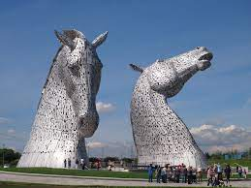 Answer: _ _ _ _ _ _ _ _
Clue 2: This country was once ruled by Tudor Kings and Queens.
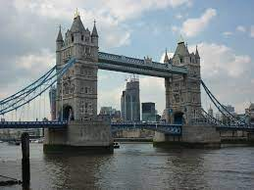 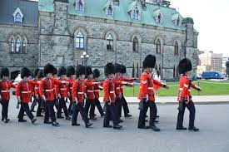 Answer: _ _ _ _ _ _ _
Clue 3: Paris is the capital city of this country.
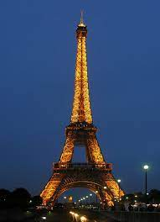 Answer: _ _ _ _ _ _
Clue 4: The national flag of this country is square.
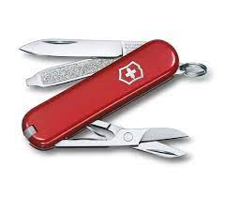 Answer: _ _ _ _ _ _ _ _ _ _ _

Clue 5: This country is shaped like a high heeled boot kicking a ball.
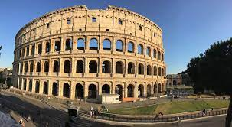 Answer: _ _ _ _ _

Clue 6: This country is the birthplace to the famous composer, Mozart.
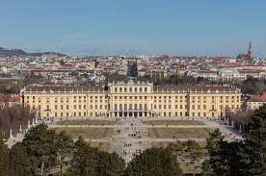 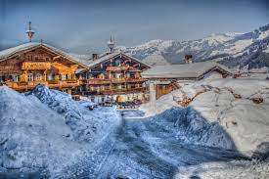 Answer: _ _ _ _ _ _ _

Clue 7: This country’s flag has the same 3 colours as the German flag.
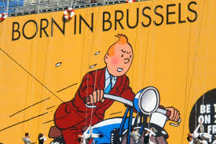 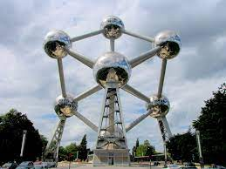 Answer: _ _ _ _ _ _ _
Clue 8: The tallest people in the world live in this country.
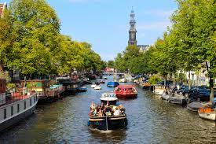 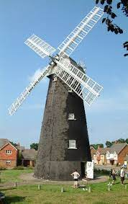 Answer_ _ _ _ _ _ _ _ _ _ _
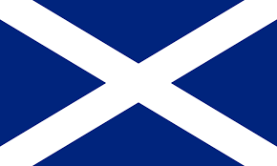 | 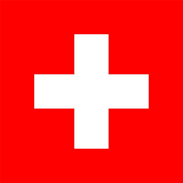 | 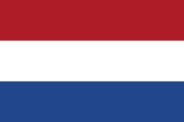 | 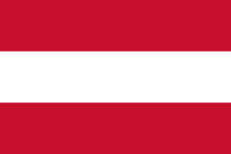
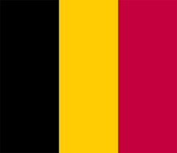 | 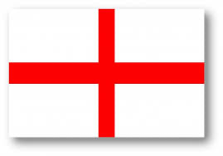 | 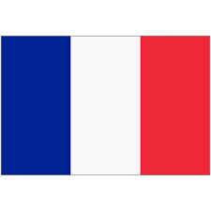 | 