To all the pupils in ……….,

Your teacher tells me you are studying Titanic and so I thought I’d let you know about a children’s novel I’ve written which is set in April 1912, on board RMS Titanic.
My publisher Cranachan Books asked me if I’d be interested in writing a Titanic set story, if possible with a Scottish protagonist. I agreed to give it a go, although was rather scared by the amount of research I was going to need to do. The only Scottish accent I remembered hearing in the Titanic movie fwas William Murdoch’s. Murdoch was the Chief Officer aboard the ship, and at 39 years old wasn’t the ideal main character for a children’s novel!
Luckily, research of the Titanic’s passenger list revealed that the perfect character had been travelling in 2nd Class; 12-year-old Bertha Watt, who was from Aberdeen in Scotland.
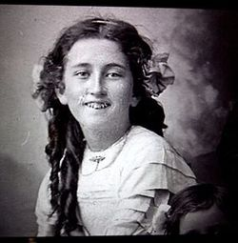 Bertha Watt
She was perfect, not only because she was Scottish but because her dad had travelled to their new home in Oregon on a different ship six months earlier. This was a very good thing, because most of the men in 2nd Class didn’t survive the sinking.

On the 10th of April Bertha Watt, dreamer and would-be polar explorer, and her mother, Bessie, boarded the Titanic to begin their journey across the Atlantic to join Bertha’s dad..
So, I had my main character, but my story was in desperate need of a thrilling plot. Luckily, newspaper reports from the time gave me the necessary scoop. One of the passengers in 2nd Class was not who he claimed to be! My twist on this historical fact was to turn Bertha Watt into a detective, one who is determined to solve the mystery of the mysterious widower Mr Hoffman.
Convinced that Mt Hoffman is up to no good, Bertha sets up The Titanic Detective Agency with the help of her new friend, Marjorie Collyer, known as Madge.
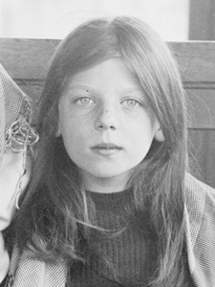 Marjorie Collyer
When Johan Cervin Svennson, a Swedish lad travelling alone in 3rd Class asks for help in deciphering a map he has discovered, Bertha adds The Strange Boy and the Treasure Map to her case book. Bertha and Madge work on solving the mysteries, both unaware that the ship is steaming towards disaster and that time is running out for hundreds of those on board.

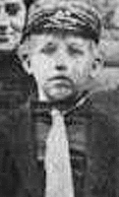 Johan Cervin Svennson

As for Johan, his part in the story is just as important. It wasn’t hard to imagine his fear and worry, leaving his mother and younger siblings behind in Sweden and travelling alone across the Atlantic towards a hard life as a farm labourer.
When I was researching the characters’ life stories, I had to consider carefully what details to include, as while there is no getting around the fact that the Titanic was a desperately tragic event, it was important not to make the ending too sad for young readers. This was where the case of the mysterious Mr Hoffman was useful, as the story of what happened to Hoffman’s two cute little boys is probably the closest it is possible to get to a happy ending aboard the Titanic.
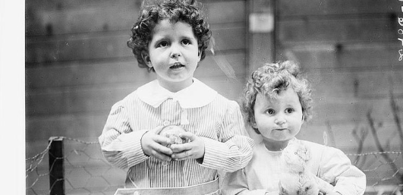
I would be really pleased if you could read my book and tell what you think of the real-life characters and the plot. Do write back and let me know!
Have a brilliant term.

All the best,

Lindsay Littleson

