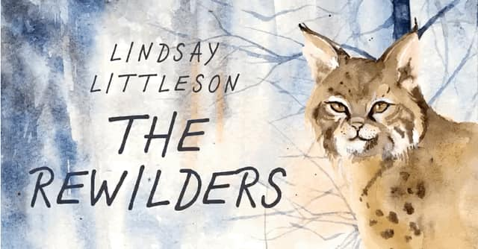

Dear ………
I’m delighted to hear you that you have my novel, The Rewilders, in your class library! When my publisher asked me to write a novel about the subject of rewilding, my mind immediately went to lynx, bears and wolves. Then I began my research and discovered that the current focus of the rewilding movement in Scotland is on restoring our precious peatlands and temperate rain forest. The hope is that by planting native trees and reviving damaged peatlands, Scotland’s biodiversity will increase and natural processes will be revived. Scotland’s temperate rainforests are internationally important and The Alliance for Scotland’s Rainforest has been set up to help restore these precious habitats. And then, perhaps, it might be time to talk about reintroducing large predators to Scotland….
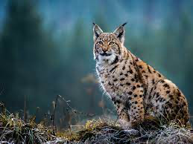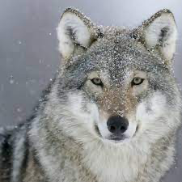

Reintroducing lynx and wolves would be an excellent way of keeping deer on the move, helping to prevent overgrazing and the destruction of young trees. And as Callum tells Esme in The Rewilders, Scotland was once home to both these large predators.

Of course, the reintroduction of wolves and lynx is controversial. Not everybody agrees that reintroducing large predators is a feasible idea, and in The Rewilders I’ve tried to show that different points of view are valid and that compromise and consensus will be necessary if these animals are ever going to be successfully reintroduced to Scotland.
Personally, I am in full agreement with David Hetherington, author of The Lynx and Us. “When it comes to reintroducing carnivores, starting with lynx is the logical first step…lynx aren’t a physical threat to humans.”
These stunning animals are so reclusive that seeing them in the wild would be unlikely, but their presence would certainly make a walk in the Highlands a more thrilling experience!
The inspiration for the plot of The Rewilders came all the way from Canada. I read an article online about a Canadian who was riding his bike along a wooded trail in Quebec when he heard a pitiful mewling sound. The man got off his bike and hunted through the undergrowth until he discovered a starving, bedraggled kitten. Quickly realising he’d found a lynx kitten rather than a domestic cat, he took the little creature home and called wildlife experts.
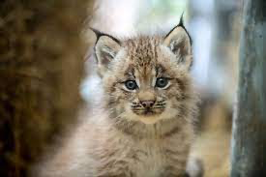
When I finished reading the article, I asked myself the question, What if?
What if two old ladies, out for a walk on a Highland Estate, came across an abandoned kitten, and took it home, believing it to be a domestic cat, and only realised it was a lynx once the animal had grown to size of a Labrador?
Sadie and Jean have been banned from the estate, having been involved in an unfortunate altercation with the manager, so Esme and Callum are tasked with the problem of reintroducing the lynx to the wild. Both children, in different ways, are struggling at school and the story is as much about their emotional journeys as it is about the physical quest.
My hope is that if The Rewilders is read in class, it might inspire pupils to discover more about rewilding and to think of ways to help bring our natural world back to life.
The chapters are written from both Callum and Esme’s perspectives, and will hopefully enable class discussions about how our words and actions can impact others and about ways of making the school environment more welcoming and inclusive. There’s always room for improvement!

I really hope you enjoy The Rewilders. Do let me know what you think.
All the best,
Lindsay Littleson

