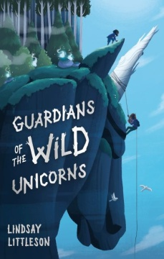
Guardians of the Wild Unicorns
Find all the hidden words!

h q g v g w x o g z w v x a e  u s y a q d a n g e r o u s a  n u z q e b m d e p i r s q f  t m a g n i f i c e n t e u q  e w t l i h h o l x t o c m c  d o k a p r k p y m i m r p l  b n m m i i m q u h m y e t l  p d v j j r a r e g i t t u h  t e r r i f y i n g d h f t t  y r j e l u s i v e a i f n u  x f y s q g b v u n t c w c k  h u d c e c h i s u i a b q b  i l f a d q a n a o n l g h s  i a j r j c o e w i g j r o u  f x e y b m b s t u n n i n g | hunted  magnificent  beautiful  stunning  dangerous  scary  intimidating  wonderful  rare  elusive  secret  terrifying  mythical

Draw the wild unicorns in magical Whindfall Forest.

A Scottish Unicorn

Can you design a very Scottish unicorn?
Think of Scottish symbols such as tartan, the thistle, the Saltire, the lion rampant, the golden eagle.
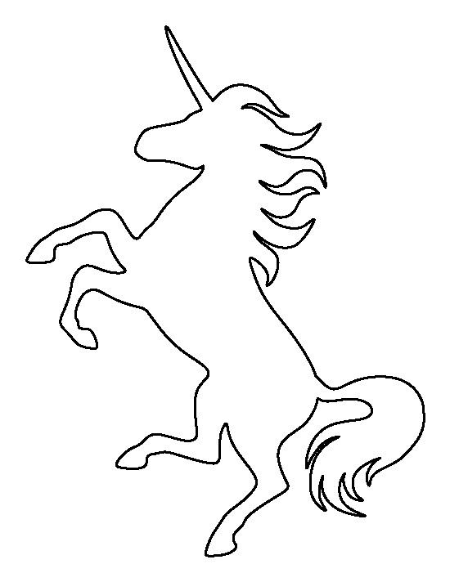

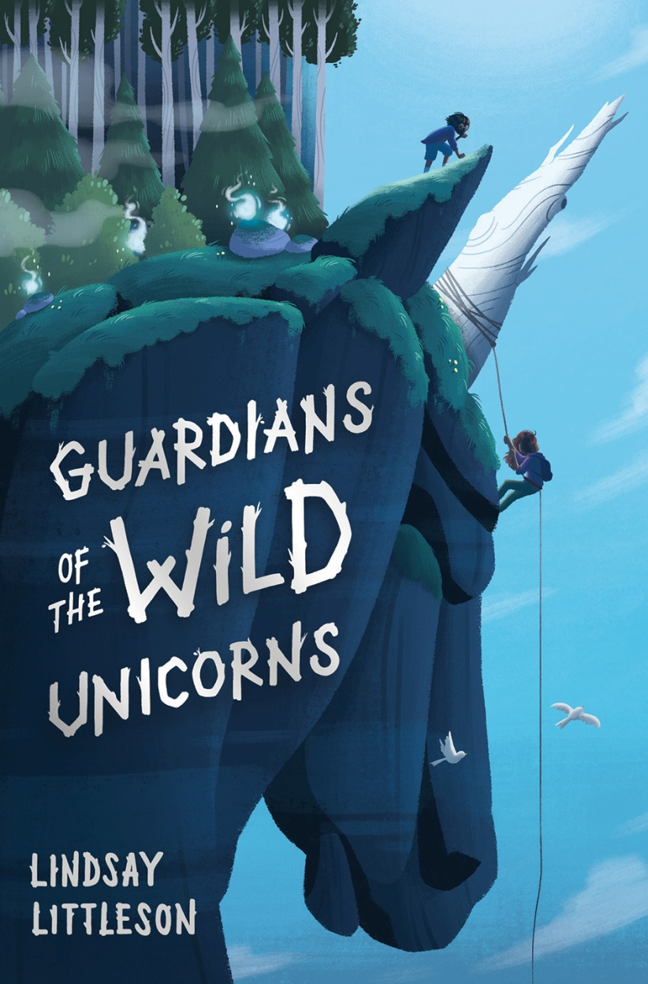
Design a new cover.

- Read the blurb on the book cover and use it to help you create a new cover design.

- Decide what text should go on the front, the back and the spine.
- Next draw a rough design.
- Choose a colour scheme. Think of the title of the book. What colours might suit the theme?
- Lay out your paper for the cover as below and remember that the left will be the back and the right will be the front when it is folded onto the book.
Back | Spine | Front
Which way will you write on the spine so that you can read it on a bookshelf?

